Activity: Map your researcher skills and look for strengths and gaps

A great tool for this is the [Researcher Development Framework online planner](https://rdfplanner.vitae.ac.uk/), which is available to University of Bristol researchers. You will need to use your Bristol emails address to register and log in to the website. Once logged in you can use the interactive tool to explore the range of skills that researchers have to offer and to plot your own skills inventory showing the skills you have developed and identifying any gaps or development areas.

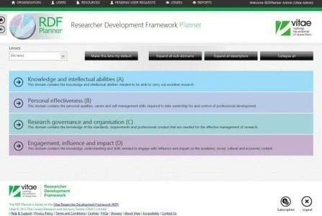

The online tool enables you to:

* Identify your expertise and capabilities
* Plan your career
* Focus your training effort where it is needed most
* Record and showcase your achievements
* Monitor your progress
* Use in professional development review meetings with your supervisor or PI

Once you have identified your key skills you can:

* Think about how to market and describe them to future employers [see [section D2](http://www.bristol.ac.uk/staffdevelopment/academic/researchstaffhub/developing-career/career-planning-toolkit/take-action/evidence-skills/)]
* Make plans to develop new skills to enhance your employability [see [section C3](http://www.bristol.ac.uk/staffdevelopment/academic/researchstaffhub/developing-career/career-planning-toolkit/decide-plan/skills-development/)]